Lab 10 Submission: Johnathan Schaff

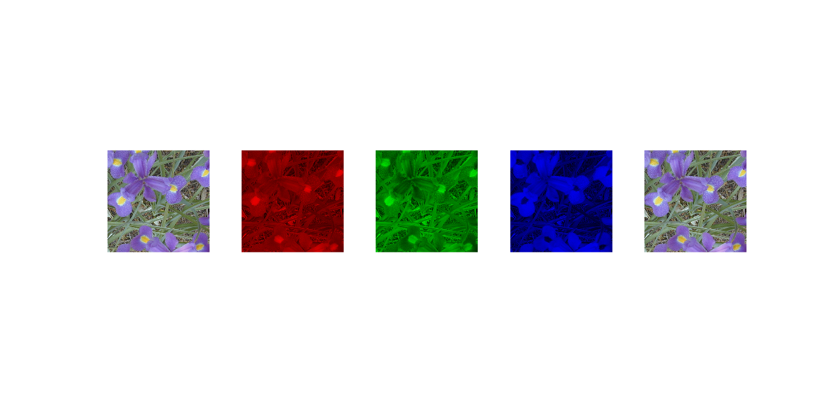
Part 1

Description: Loads the original image, and then displays the red, green, and blue image component scales for the image. Then the last image is the combination of the three rgb components to achieve the original image again

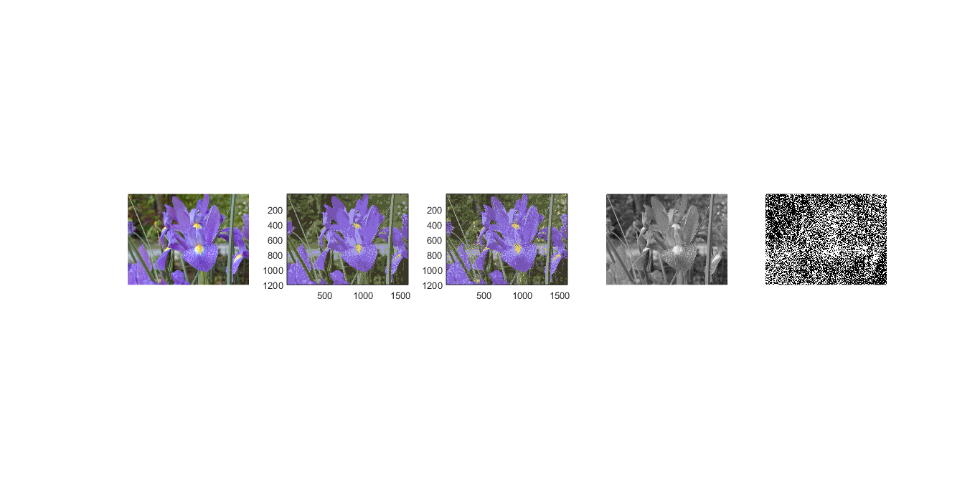
Part 2

Description: Loads the image, and the displays the image with only 8 colors with and without dithering. Then the image is converted to grayscale and then shows the dither of the grayscale image

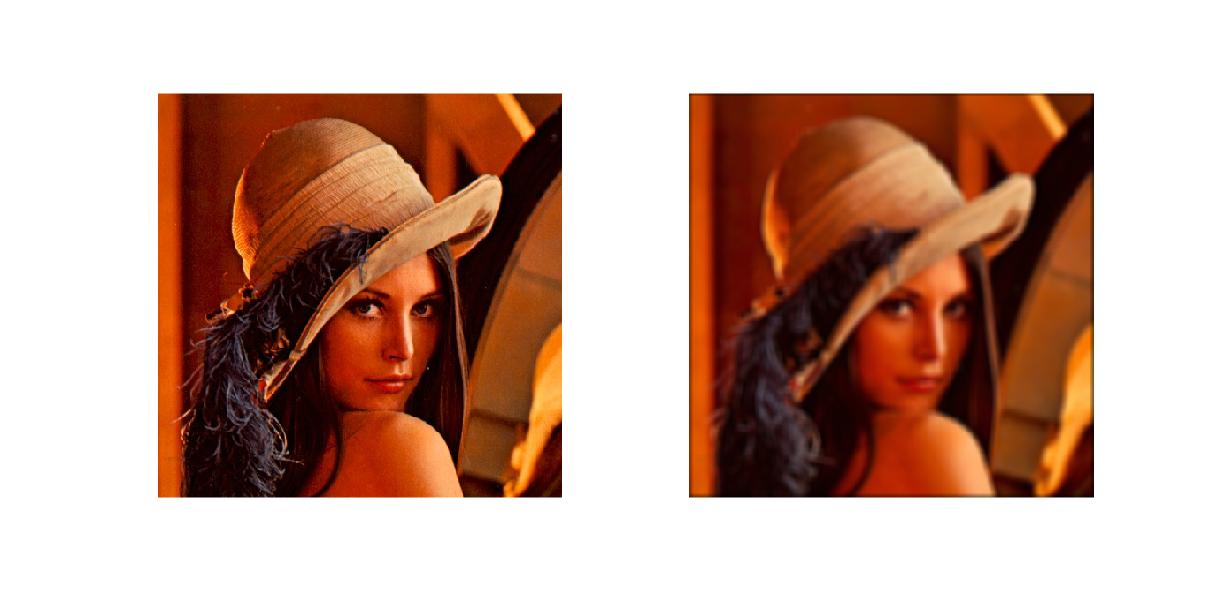
Part 3
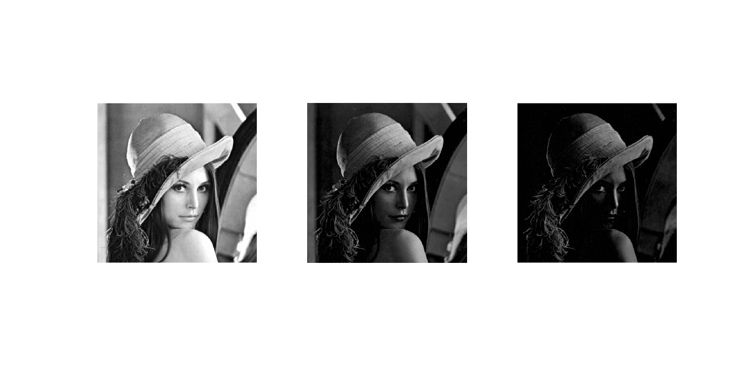

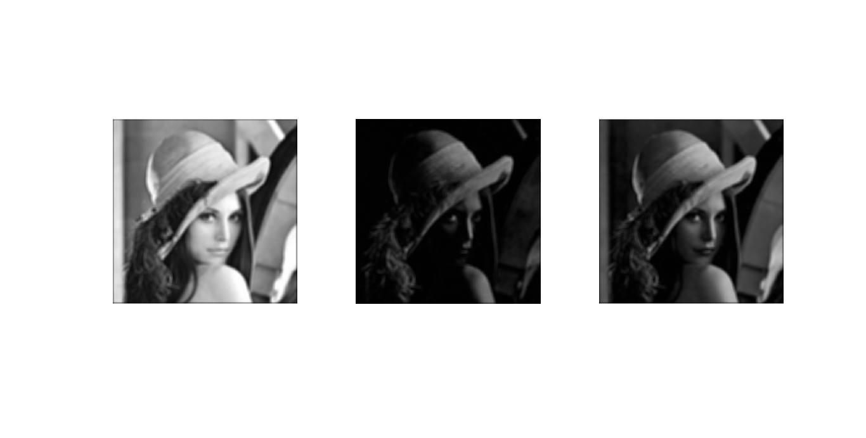
Description: Loads the original image, then breaks the image up into its original RGB components. Then I apply an average filter to each of the RGB components and combine to get the smoothed image

Part 4

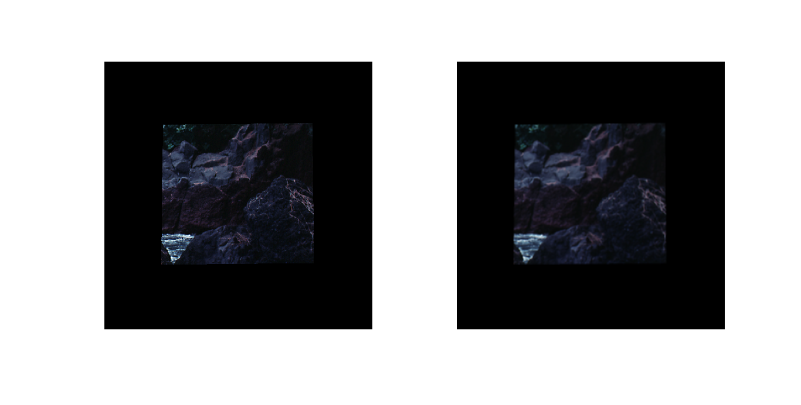
Description: Loads the original image, then uses the roipoly function to allow for isolating a part of the image. Then the isolated part is shown next to the smoothed image via an average filter

Part 5

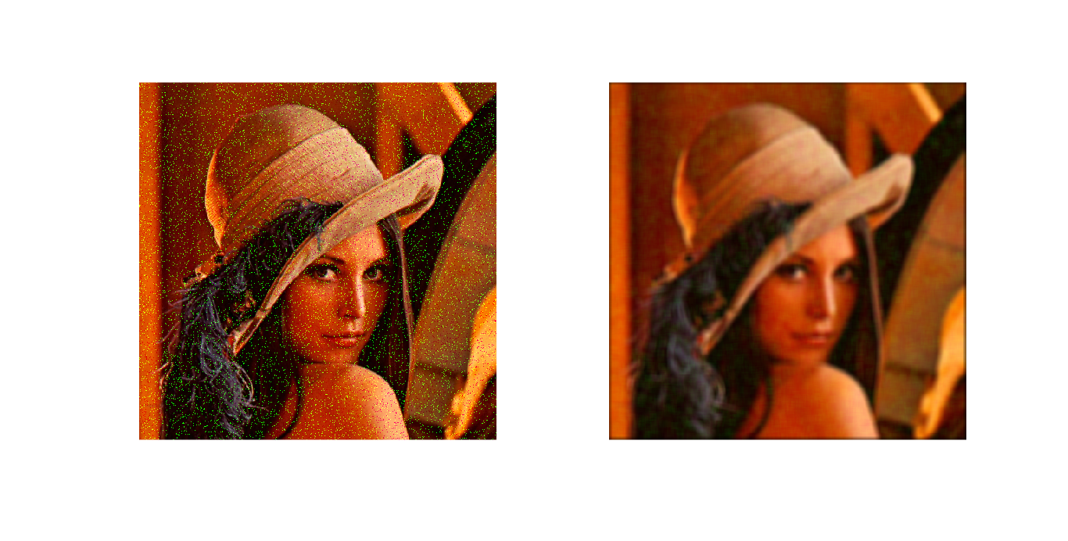
Description: Applies the same technique used in part 3 with a different image to demonstrate how the noise could be removed from the image.

